# How to

The scene starts with an animated camera flight (30 sec movie) afterwards you can move around and explore the world. Use the arrow keys / AWSD to move around. To change the camera look at direction simply make left mouse click on the canvas and move the mouse to wherever you want the camera to look at. If you don’t want to sit through the camera flight, immediately want to explore simply press “C”.

* Up/W – Move Camera position Forward (to Camera Look at Direction)
* Down/S – Move Camera position Back (from Camera Look at Direction)
* Left/D – Move Camera position Left (from Camera Look at Direction)
* Right/A – Move Camera position Right (from Camera Look at Direction)
* Mouse Left – Move Camera look at
* C – Stop the animated camera flight
* R – Resets Camera to look at

Here is an overview screenshots of the world for better orientation.

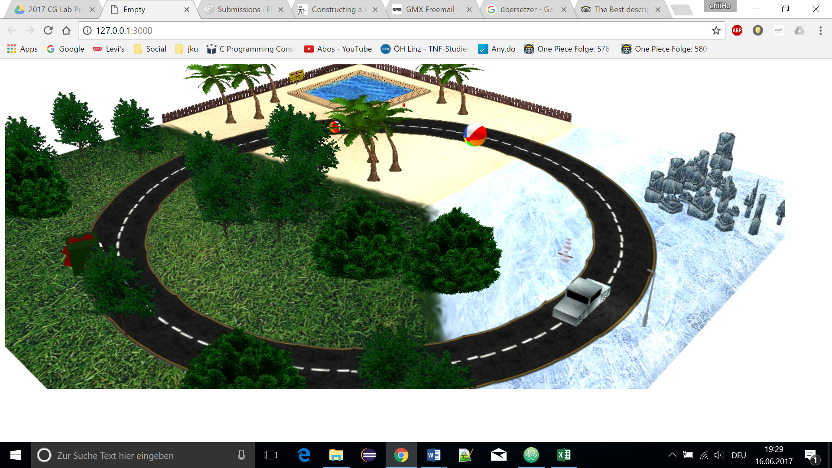

The world contains three different scenes

1. Forest with multiple trees and a dragon that starts flying up and down if you get closer.
2. Beach with a pool, palm trees, a fence to block off the way to the ocean and balls that start bouncing and rolling when you get closer.
3. Icy Wasteland with ice sculptures, a streetlight and two snowmen that come to life when you come closer.

# Movie Description

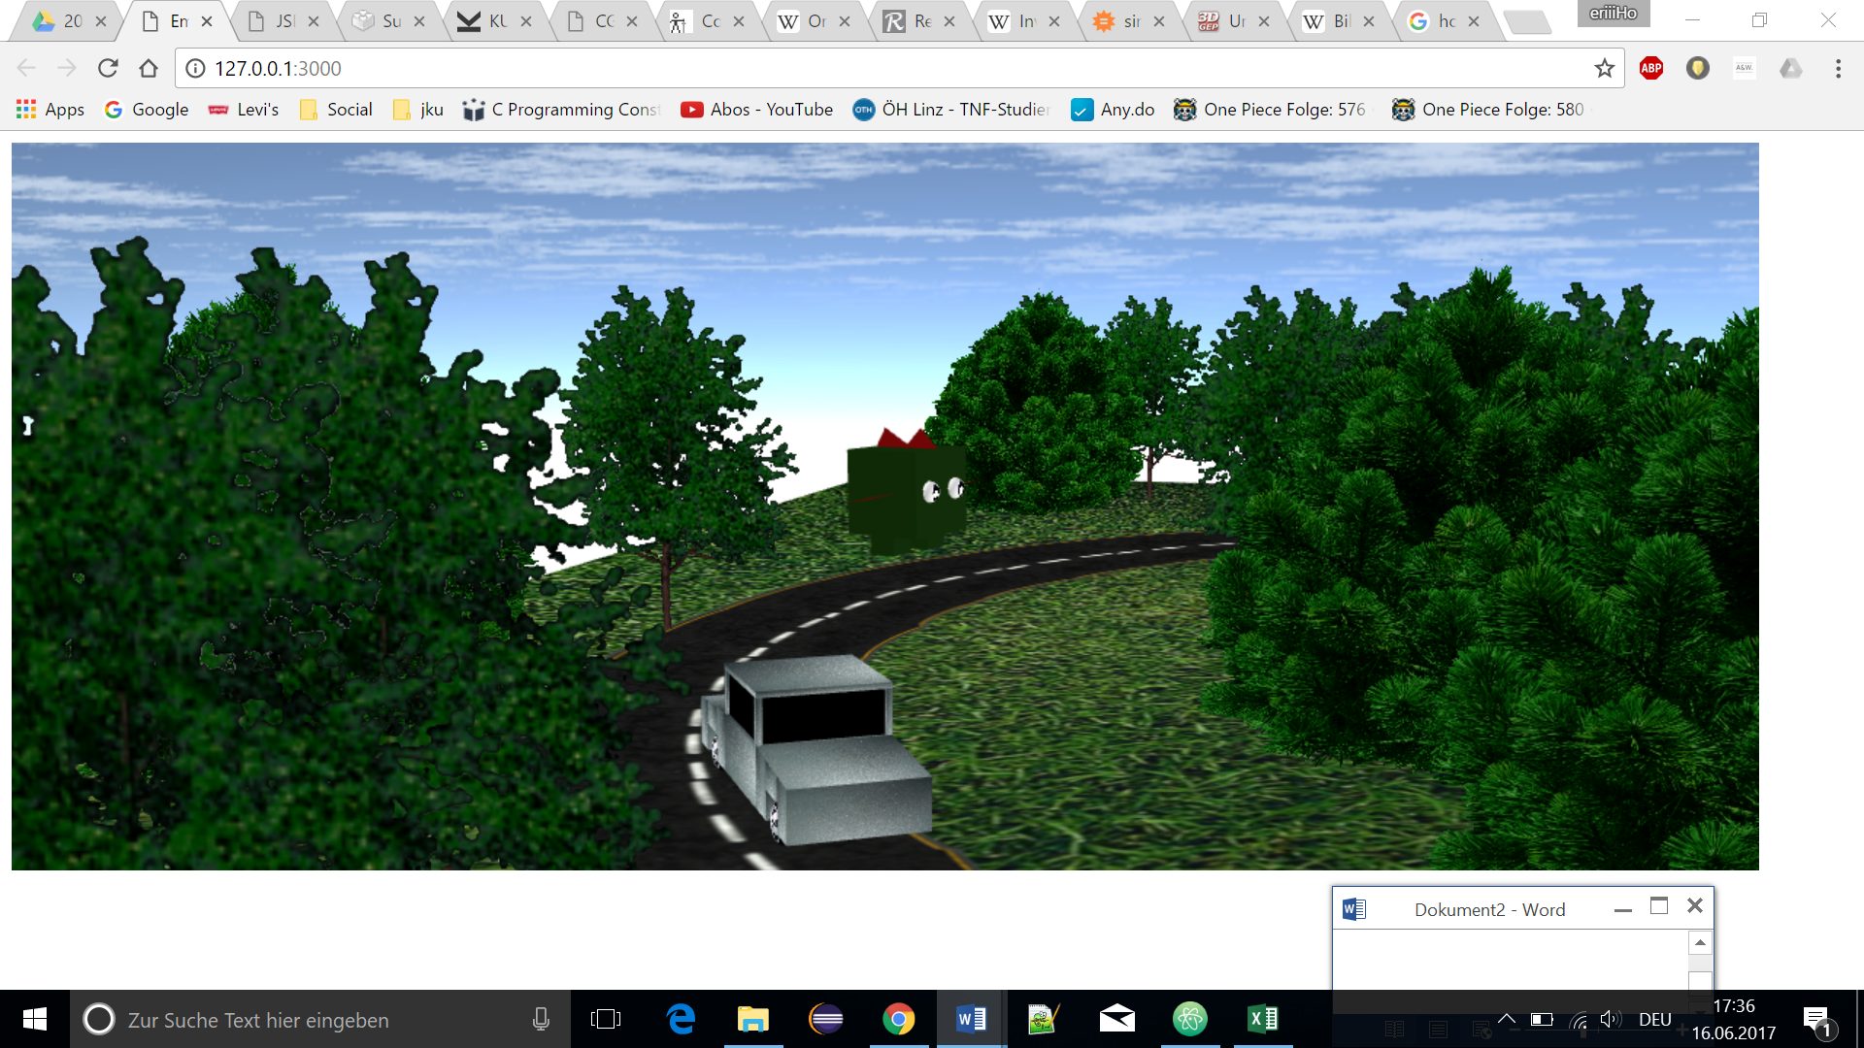

The movie starts in an enchanted forest with a race in a silver car driving along a bumpy road.

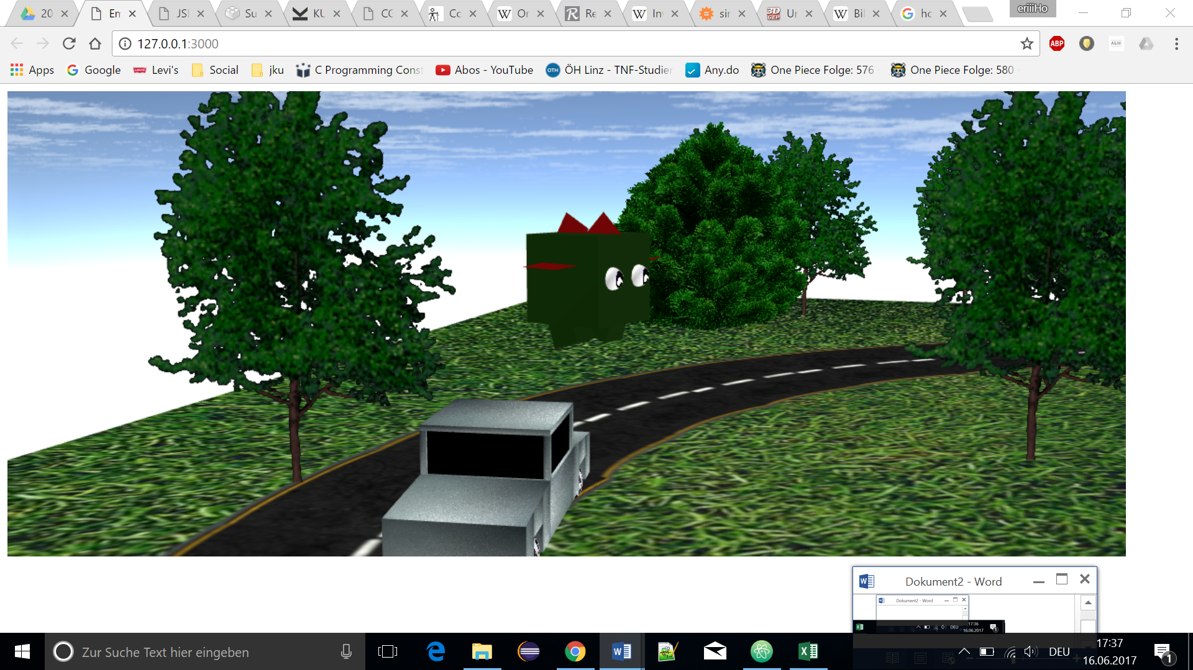

A dragon starts jumping up and down on the side of the road, flapping its tiny wings to scare the racer off.

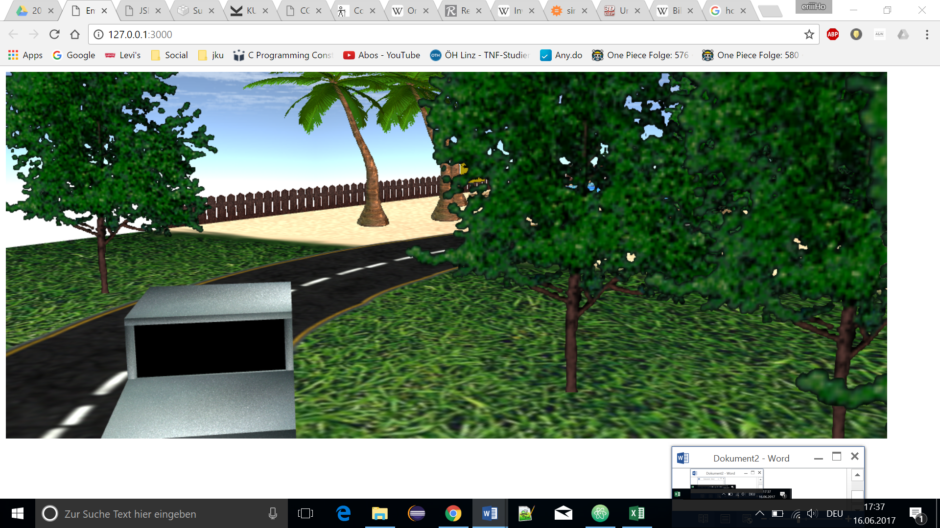

In the distance the Racer can see a clearing, so he immediately follows the road.

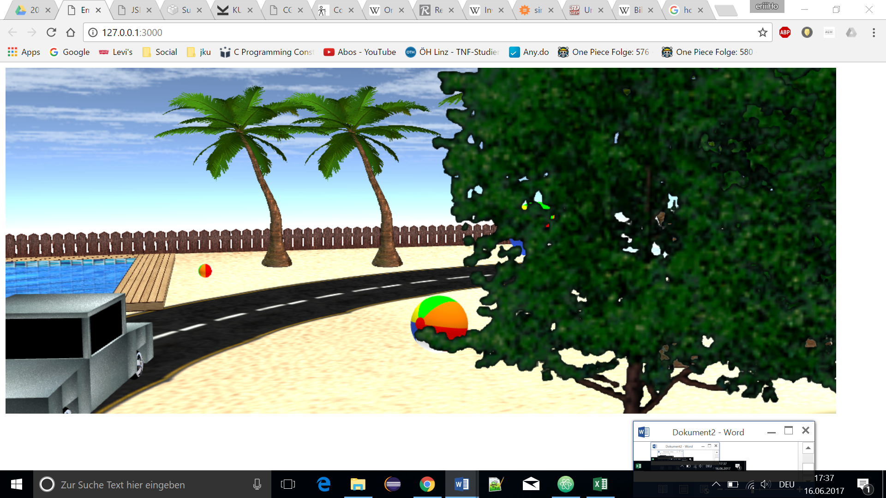

Passing a few more trees the racer finds himself on the clearing which is actually a beach.

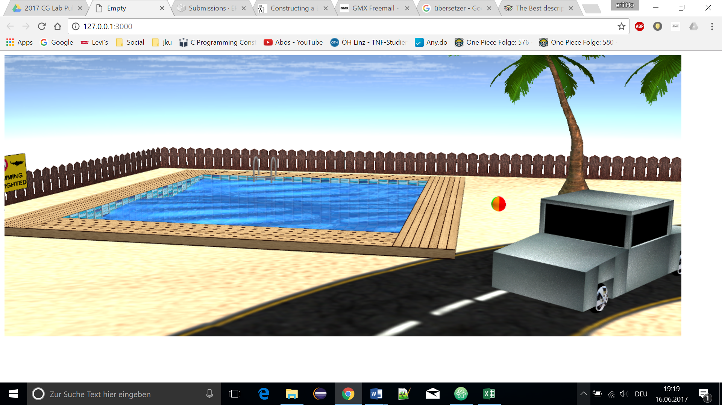

While the Race follows the road, he gazes in wonder as he sees an outdoor swimming in the middle off the beach.

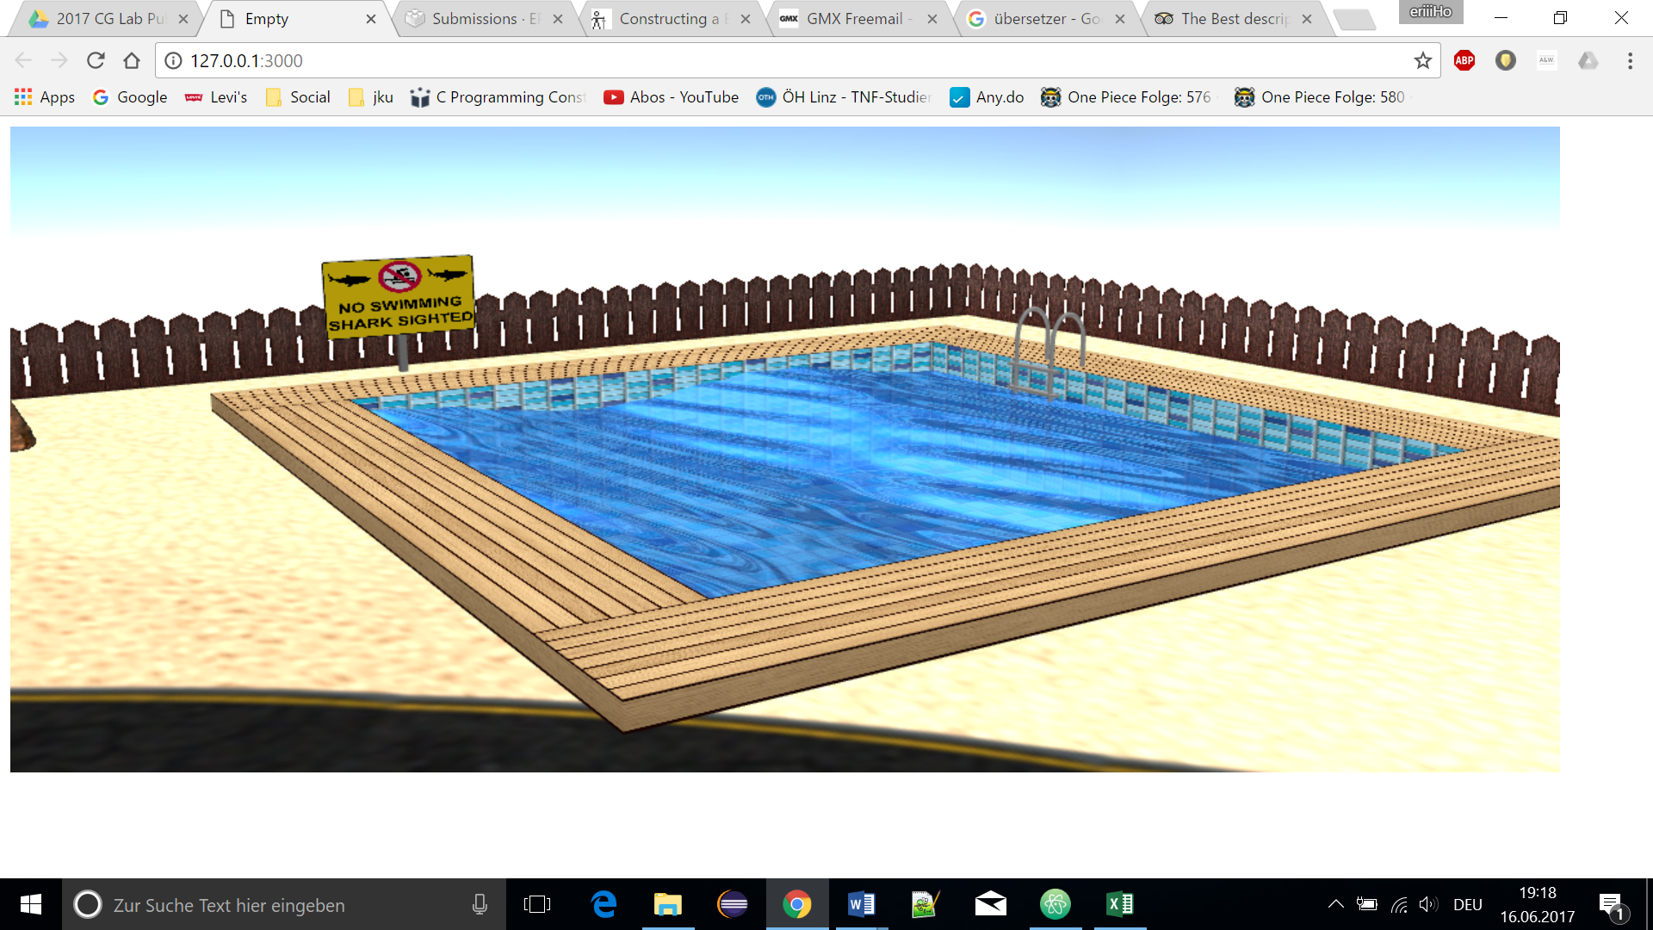

As his eyes wander further left he sees a fence with a sign that is warning about sharks in the ocean.

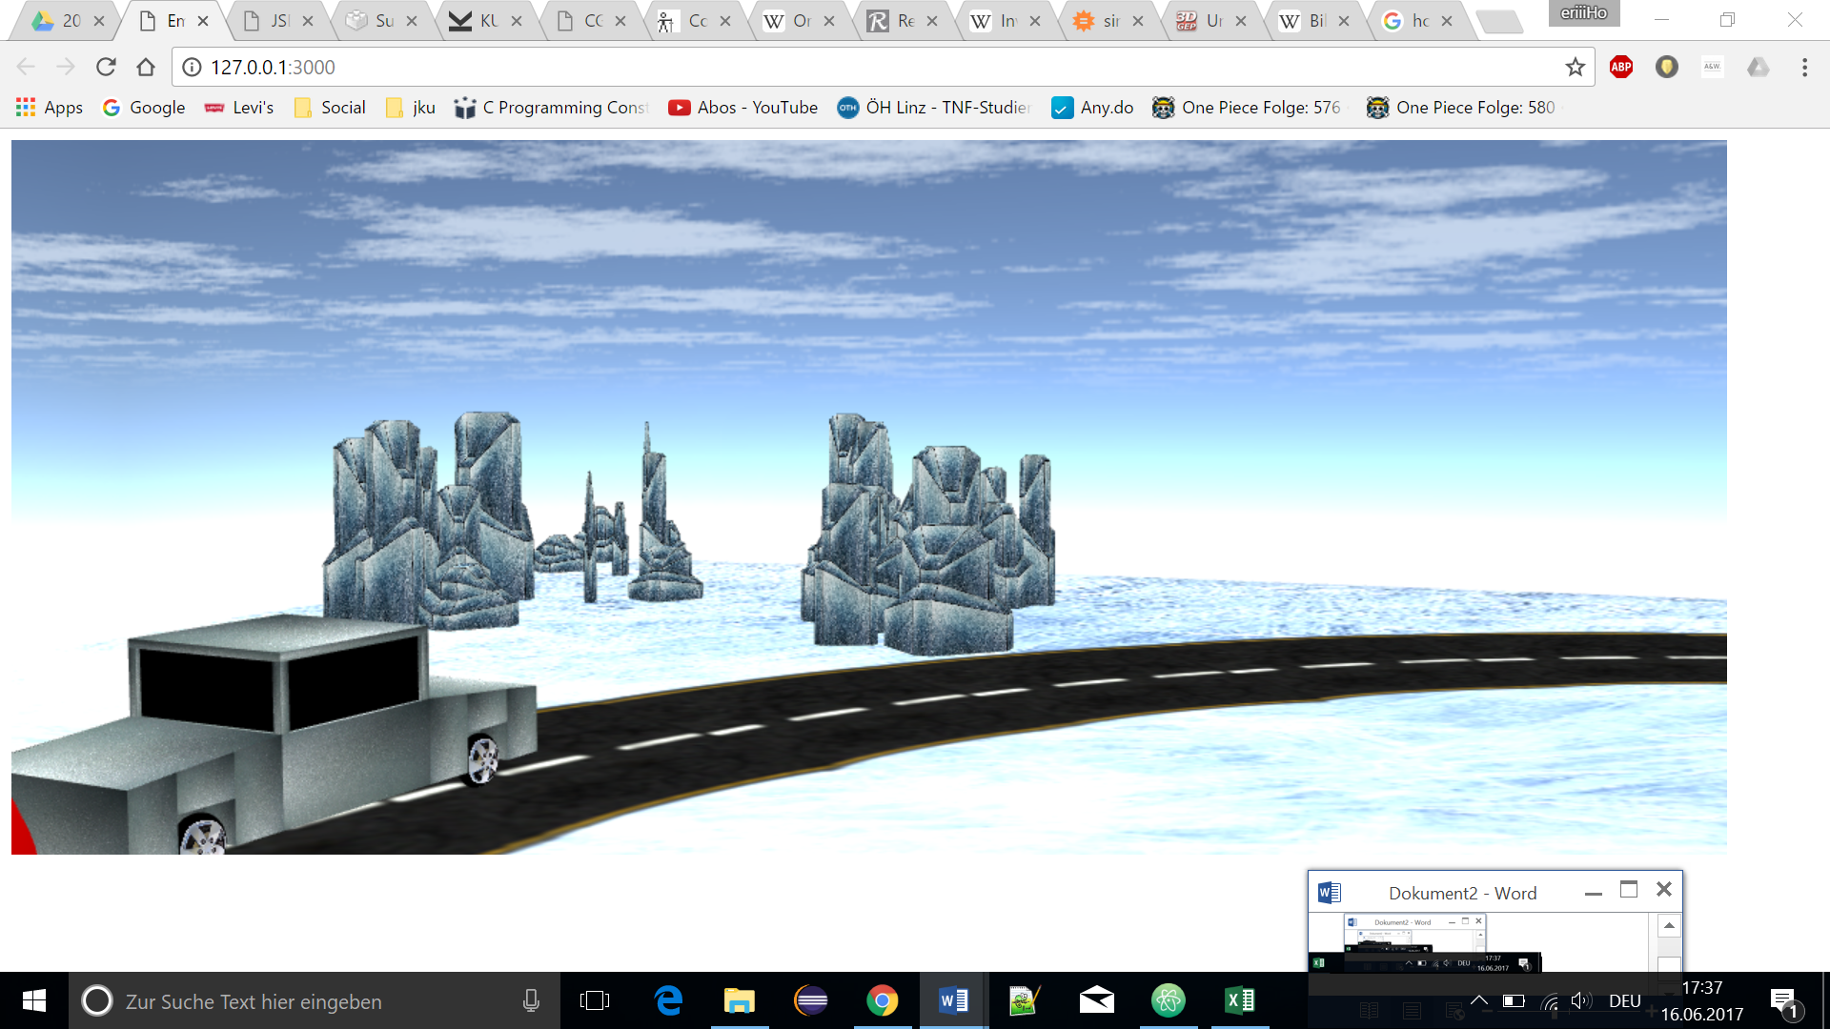

Not wanting to go near that dangerous ocean, the racer kept following the road into an icy desert. Magical ice sculptures in all shapes and sizes decorate the endless snow-white glittering landscape.

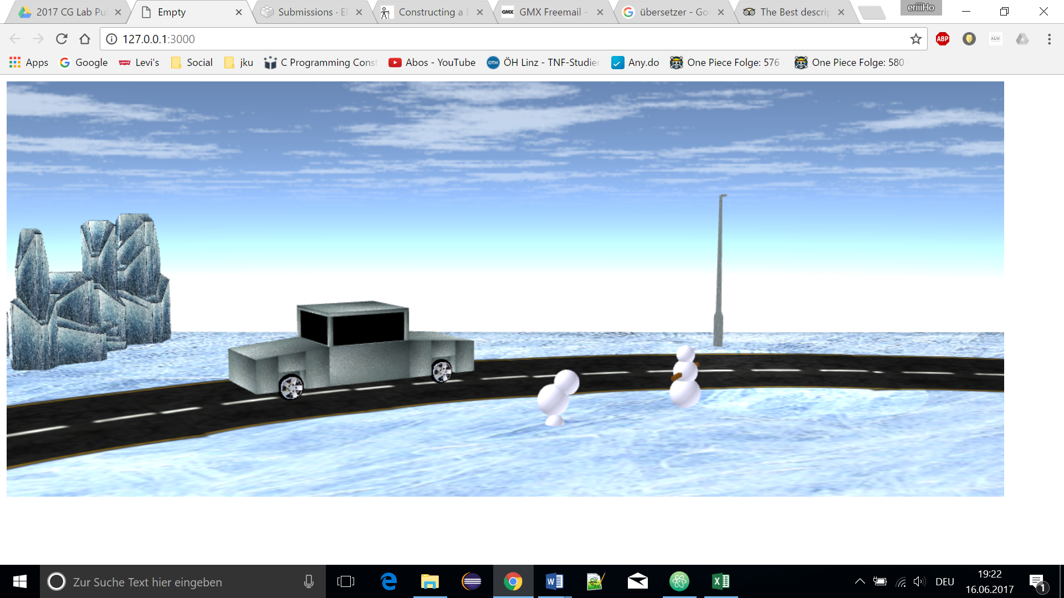

Further down the road he passes two snowmen who came to live. One already falling apart, the other running panic-struck in circles because he does not have eyes yet.

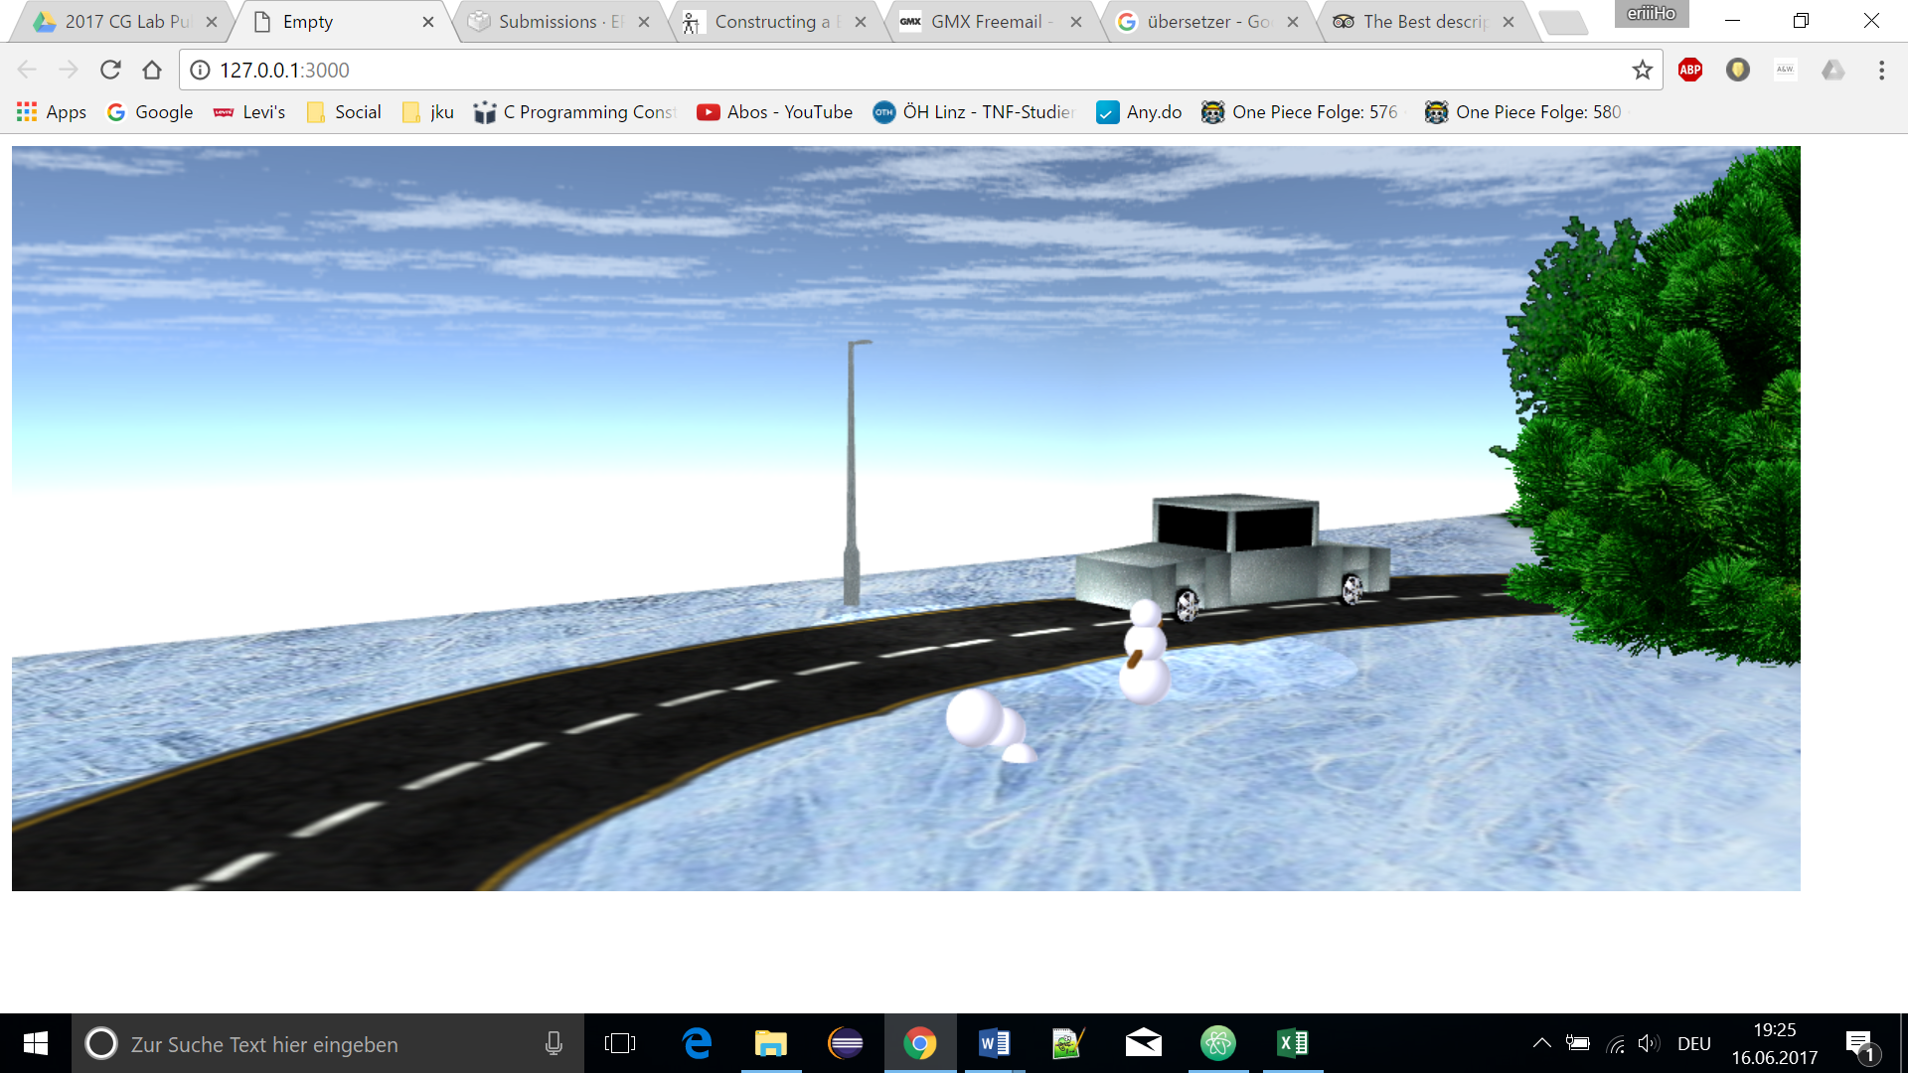

The movie ends with the car driving back into the enchanted forest, never to be seen again.

THE END